<https://jcrisch.files.wordpress.com/2015/04/descente-gradient-3d.jpg>

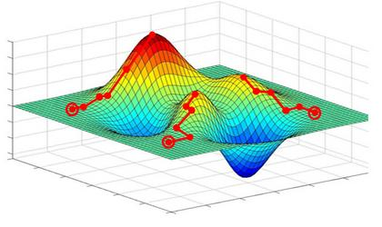

[https://cdn-images-1.medium.com/max/1200/1*f9a162GhpMbiTVTAua_lLQ.png](https://cdn-images-1.medium.com/max/1200/1*f9a162GhpMbiTVTAua_lLQ.png)

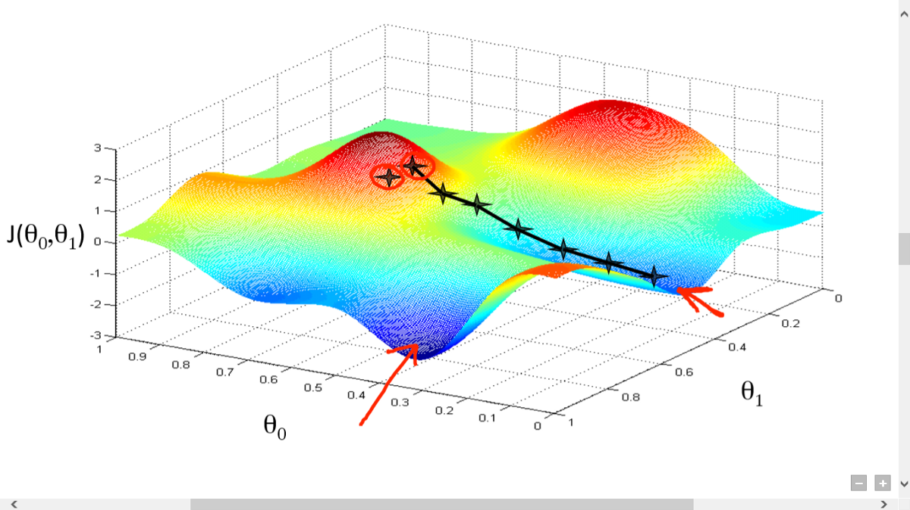

<https://th.bing.com/th/id/OIP.ZuMB_aeDxu_8U49GeTM-RAHaFj?pid=Api&w=960&h=720&rs=1>

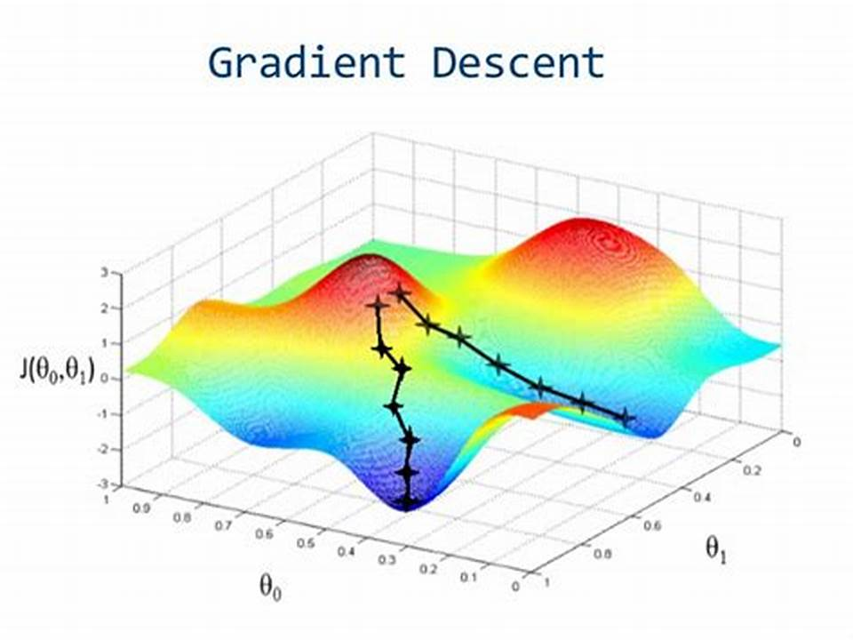

<https://ccdn.goodq.top/caches/7cec4134902a3476a595c9e1753adeb6/aHR0cDovL3d3dy5lbXBvd2Vyb3BzLmNuL3FmeS1jb250ZW50L3VwbG9hZHMvMjAyMC8wNS85MzY1MGU5MzZmMDcxZDE4ZTUzOTQ3NmIyZDc1YzgzOC5qcGc_p_p100_p_3D.jpg>

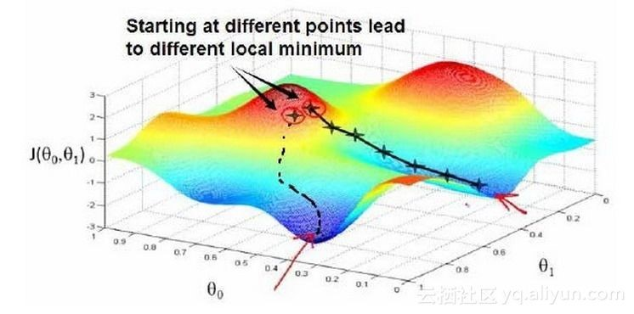

<https://ai.aspdkw.com/wp-content/uploads/2018/08/Screenshot-2018-08-23-11.14.41.png>

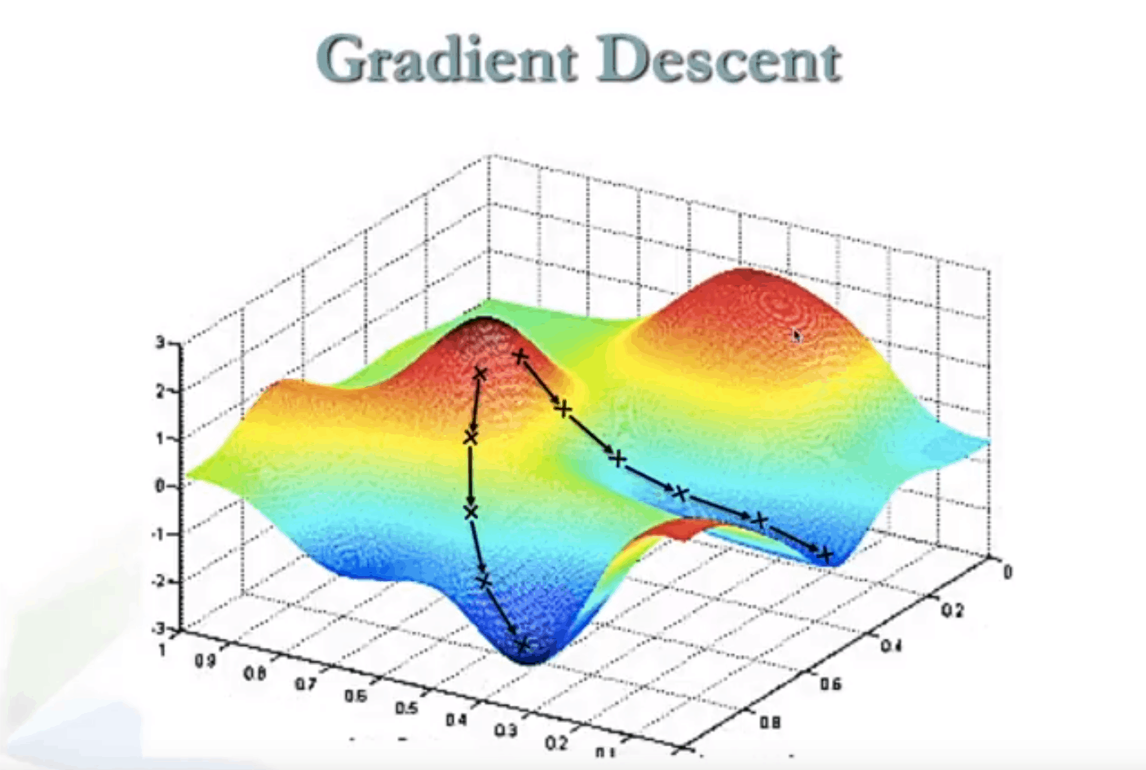

[https://miro.medium.com/max/699/1*mElyetzsTIJrNnKI8kTkCw.jpeg](https://miro.medium.com/max/699/1*mElyetzsTIJrNnKI8kTkCw.jpeg)

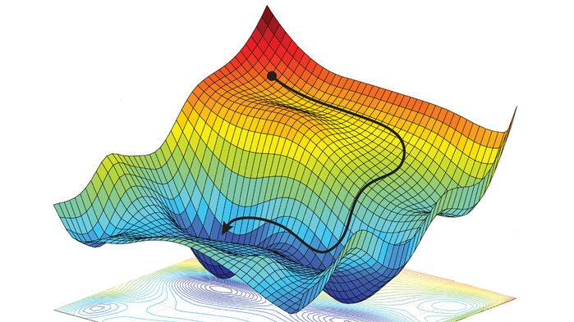

<https://i.ytimg.com/vi/7EuiXb6hFAM/maxresdefault.jpg>

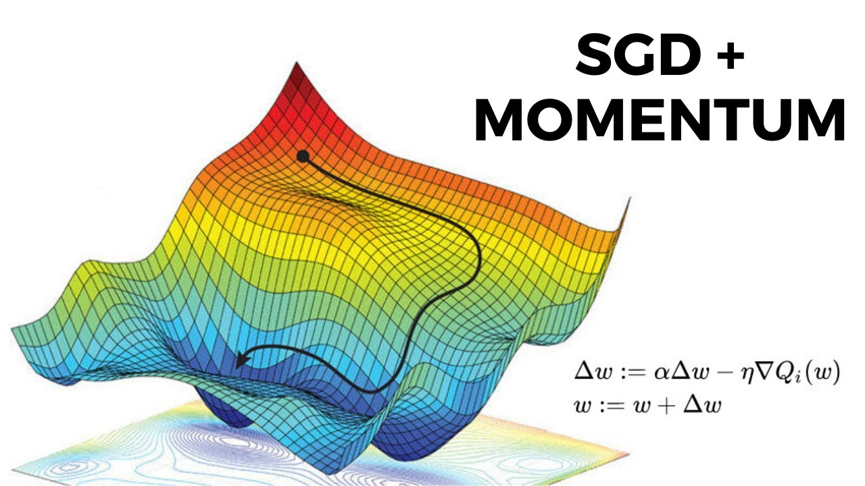

<https://i1.wp.com/ucanalytics.com/blogs/wp-content/uploads/2017/09/Polynomial-Gradient-Descent-Capatin-Kirk.jpg>

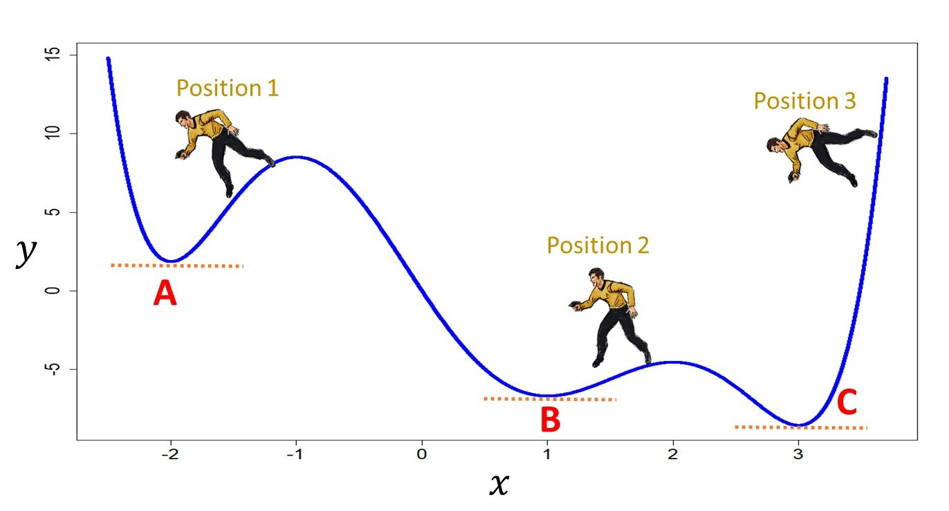

[https://cdn-images-1.medium.com/max/1600/1*PV-fcUsNlD9EgTIc61h-Ig.png](https://cdn-images-1.medium.com/max/1600/1*PV-fcUsNlD9EgTIc61h-Ig.png)

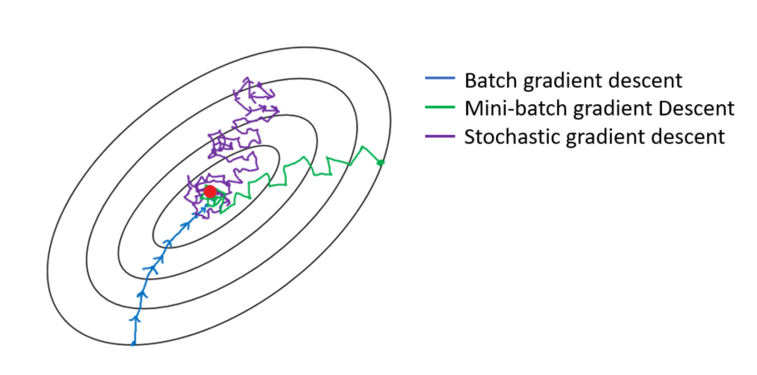

[https://cdn-images-1.medium.com/max/1200/1*msObu3xbQzSnKvtCW2z6YQ.png](https://cdn-images-1.medium.com/max/1200/1*msObu3xbQzSnKvtCW2z6YQ.png)

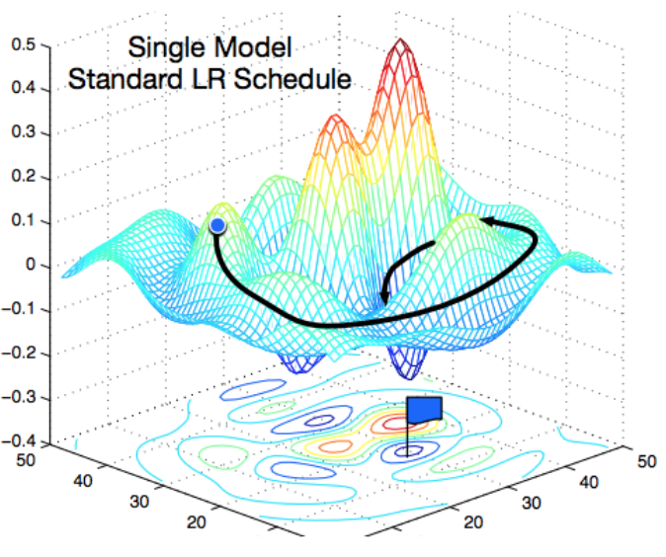

<https://th.bing.com/th/id/OIP.QYn776vmuVGLMn4Jv0c1gAHaGM?pid=Api&rs=1>

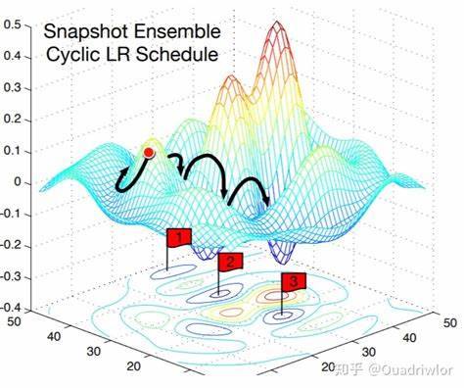

<https://i.stack.imgur.com/UCDCK.jpg>

